Posted 03/08/2012 at 1:36 pm by JAV
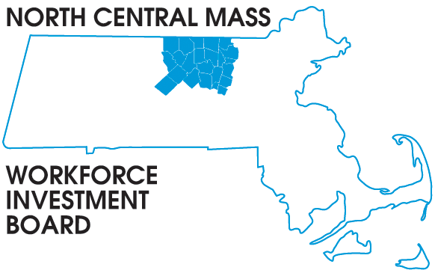
1355 Central Street Leominster, MA 01453 Phone: (978) 534 1023 Fax: (978) 534 1807

BOARD OF DIRECTORS MEETING

Tuesday, March 13, 2012

North Central Chamber of Commerce

860 South Street Fitchburg, MA 01420
8:00 a.m. –9:30 a.m.

AGENDA

Welcome & Introductions

APPROVE MINUTES of the November meeting (Vote required)

Executive Committee Report Theresa Kane (Vote required)

Mass MEP H1B grant
Presentation by Ted Bauer
Manager of Workforce Programs

Grants updates:

New Award Mass MEP H1B grant $4 million North Central WIB is a partner in this multi-regional project

New Award Employer Engagement in Youth Employment Programs $15,000 Central & North Central WIBs

New Award Community College USDOL Grant 20 million, MOU signed, project progressing

New opportunity USDOL Workforce Innovation Grant 98 million North Central WIB participating in three applications.

Energy: HVAC with Solar: 21 enrolled 18 completed training 16 certified 9 employed
BPI Building Analyst training: 19 enrolled, 17 completed, 15 certified 3 employed

Board Vacancies: Two openings for Private sector Business representatives.

Other Business:

